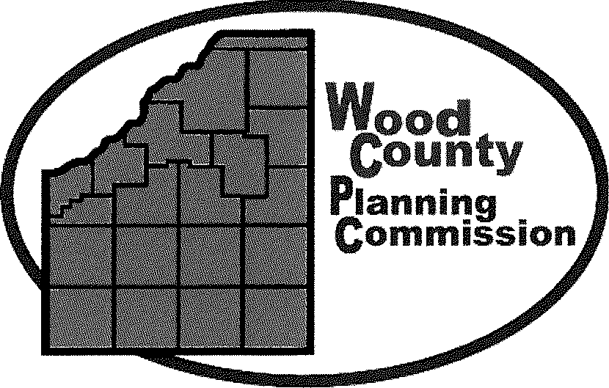

To: All parties interested in applying for funding under Wood County’s PY2022 CDBG Grant
From: Dave Steiner – Director – Wood County Planning Commission
Date: April 5, 2022

Re: PY2022 CDBG grant application

The Wood County Commissioners and the Wood County Planning Commission are pleased to announce the PY2022 CDBG "Community Development" Program. This year's CDBG Grant Fund allocation is estimated to be approximately $328,000 dollars. As has been the case in the last three rounds of funding, Wood County is limited to undertaking a total of four (4) projects only.
The Community Development dollars may be utilized in a variety of ways to further the State and Federal goals of benefiting low and moderate income persons and to aid in the elimination of slum and blight. If you have questions concerning a project's eligibility under this grant, please contact the Planning Commission Office as soon as possible and we will determine if your particular project is eligible for funding under the grant guidelines.
In order for Wood County to meet the State of Ohio's June 15, 2022 application deadline, the following timetable has been established:
Applications Due:
Applications must be completed and Three (3) copies submitted to the Wood County Planning Commission Office, One Courthouse Square, Bowling Green, OH 43402 NO LATER THAN 4:30 P.M. ON MONDAY May 16TH, 2022 TO RECEIVE CONSIDERATION.
The application can be downloaded from: http://planning.co.wood.oh.us/home/grants/

If needed, a copy of the application can be mailed, or emailed to you, upon request.
Wood County Planning Commission's Evaluation:
The Planning Commission staff will pre-screen each application for completeness. These applications will then be reviewed by the Planning Commission members during their session on Tuesday, June 7th , 2022 at 5:30 P.M.

One Courthouse Square, Bowling Green, Ohio 43402 Phone: 419-354-9128 Fax: 419-373-4972
www.co.wood.oh.us/planning

It is the hope that the completed Community Development Needs worksheet that was completed in 2022 will help to rank and prioritize community needs and aid in project selection. The Planning Commission members will then recommend the agreed upon project list and funding amounts to the Wood County Commissioners for final consideration and selection.

It is very strongly encouraged that a member of the applicant's governing body be present at the June
7, 2022 Planning Commission meeting.

Wood County Commissioners' Public Hearing:
The Wood County Commissioners shall conduct a public hearing to select projects and funding levels in the month of June of 2022. The official time and date of said hearing will be announced at the June 7, 2022 Planning Commission meeting.

Applications Due:
Wood County's application to the State of Ohio is due on June 15, 2022. The following should be kept in mind when formulating your local program and application:

- Photographs must accompany applications, when applicable. ALL defined projects such as water lines, street resurfacing, ADA upgrades, etc., we will need photos in two different scales; "up close" photos that show the current condition of the site, and large scale photos that show the overall view of the project area. If it's a public service project or exact locations are unknown, you would be exempt from this requirement. Please ask if you have any questions.
- Wood County can fund up to four (4) individual projects at an average project cost of $71,800 dollars. This figure is achieved by subtracting 12.4% of the allocation amount for administration costs and dividing the remaining amount by four (4).
- Wood County's overall application must achieve a 51% benefit to low-moderate income persons.
- AN APPLICANT MAY SUBMIT ONLY ONE (1) APPLICATION. If the applicant wishes to undertake more than one project, these projects must be combined into and be part of one
  - single application.
- The use of income surveys to demonstrate benefits to low and moderate income persons or households are strongly encouraged. The State of Ohio has instituted revisions to its Income Survey Methodology and has updated LMI statistics for each community (this information was previously distributed, and can be found on our website). If a proposal is made for a public facility project (water, sewer, storm drainage etc.) that will benefit a portion of a neighborhood, an income survey will be required to document that the service area has a greater than 51% low to moderate income population. If a village or census tract is listed as 51% or greater LMI on the attached OHCP Notice, then no income survey will need to be completed. Please also note that if an income survey is conducted, it must be done in strict accordance with the process outlined in the 19-02 Policy Notice (located on our website). It is advised that a community looking to perform an income survey strongly consider contracting with a firm or agency that is experienced in conducting and drafting these surveys. You may contact the Planning Commission office if you have any questions regarding this process.
- The use of building and infrastructure surveys are encouraged if it is wished to pursue the slum or blight elimination goal. In addition to survey results, a signed letter from the C.E.O. of the Community and a map of the area are required. Survey forms and methodology are available from the Planning Commission Office.

- Cost estimates for all projects must be developed or certified by an independent third party (i.e., a registered engineer), detailing material and labor costs (Davis Bacon Federal Prevailing Wage Rates). It must be stressed that local project cost estimates be realistic and accurate. On occasion in the past, projects selected for funding did not include necessary costs associated with engineering, surveying, staking, design and inspection work. In those cases, the local government was responsible for absorbing these costs. Please ensure that all cost estimates include and clearly list the necessary Davis Bacon Wage Rates and useful life information.
- Please remember that all local projects must be submitted to the Planning Commission Office by
WEDNESDAY, MAY 16, 2022 BY 4:30 PM.
- Do not hesitate to contact the Planning Commission Office should there be any questions, comments, or concerns. The phone number is: 419-354-9128.

This application, as well as other grant correspondence can be found on the Planning Commission website:
http://planning.co.wood.oh.us/home/grants/

